**5/1/2025**

**Acrylic Urethane Sealers**

**DAS4021 White / DAS4025 Gray / DAS4027 Dark Gray**

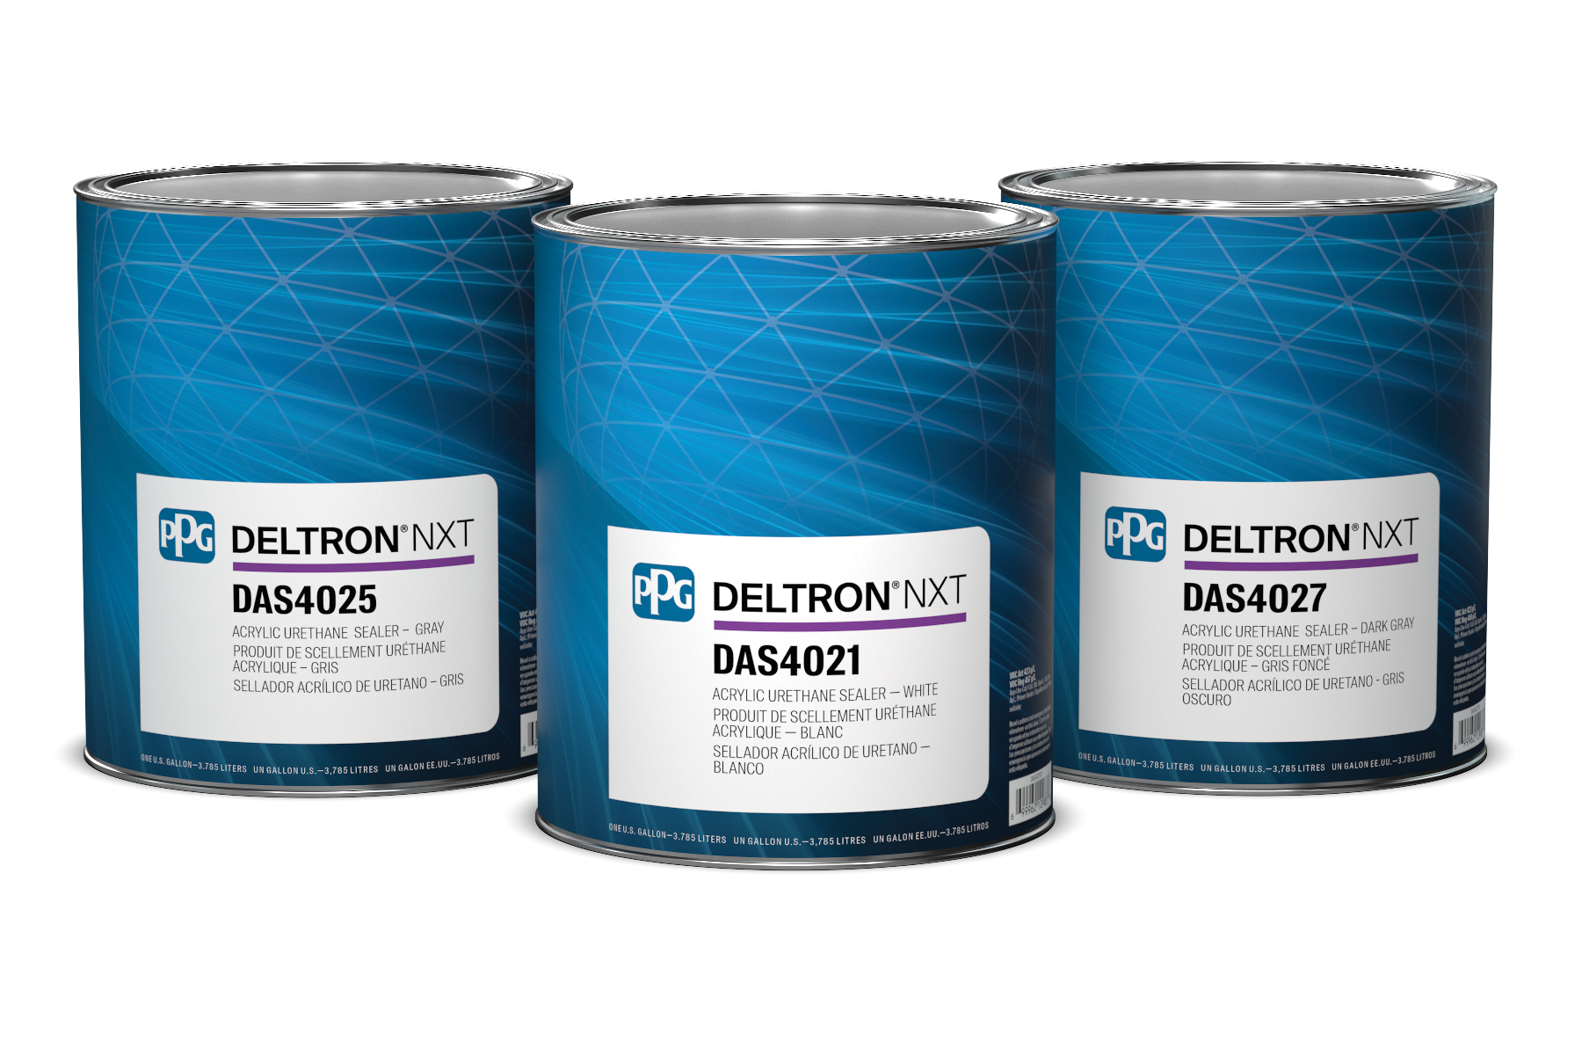

**Product Information:**

We are excited to announce the launch of the PPG DELTRON® NXT™ DAS402x Series Acrylic Urethane Sealers. These high-performance sealers are available in 3 colors, are compatible with *Deltron* NXT and PPG ENVIROBASE® High Performance basecoats, and are designed to deliver exceptional results for today’s high throughput bodyshop customers.

**Features & Benefits:**

* Fast-drying technology
* Excellent flow and color holdout
* Simple 4:1:1 mix ratio
* Available in 3 colors for optimum topcoat coverage

**Ordering Information:**

|  |  |  |
| --- | --- | --- |
| **Item Number:** | DAS4021/01 | DAS4021/04 |
| **Description:** | Acrylic Urethane Sealer – White | Acrylic Urethane Sealer – White |
| **Size:** | Gallon | Quart |
| **Container:** | Round | Round |
| **Packaging:** | 2 per case | 6 per case |

|  |  |  |
| --- | --- | --- |
| **Item Number:** | DAS4025/01 | DAS4025/04 |
| **Description:** | Acrylic Urethane Sealer – Gray | Acrylic Urethane Sealer – Gray |
| **Size:** | Gallon | Quart |
| **Container:** | Round | Round |
| **Packaging:** | 2 per case | 6 per case |

|  |  |  |
| --- | --- | --- |
| **Item Number:** | DAS4027/01 | DAS4027/04 |
| **Description:** | Acrylic Urethane Sealer – Dark Gray | Acrylic Urethane Sealer – Dark Gray |
| **Item Number:** | DAS4021/01 | DAS4021/04 |
| **Size:** | Gallon | Quart |
| **Container:** | Round | Round |
| **Packaging:** | 2 per case | 6 per case |