**7/22/2024**

**Vivid Red Ruby Extreme Color**

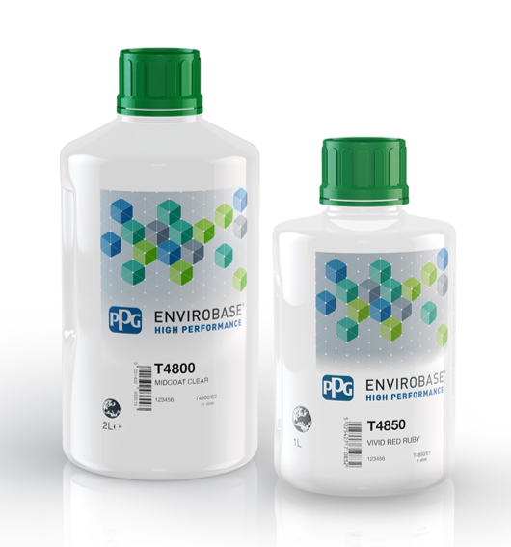**T4850 Vivid Red Ruby Toner and T4800 Midcoat Clear**

**Product Information:**

**PPG Extreme Color** presents an easier way for collision body shops to match today’s popular OEM colors with no tinted clearcoat required. As part of our Envirobase® High Performance waterborne paint system, the **Vivid Red Ruby Toner** and **Midcoat Clear** make it possible to achieve greater color performance, improved efficiency, and easier application with a full waterborne tri-coat process.

**T4850 Vivid Red Ruby** is being launched as a new toner to enhance the overall color capability of the Envirobase® High Performance color platform. The pigment utilized in this toner is particularly intense in the red color space and provides superior transparency and chromaticity.

**Color Information:**

The addition of **T4850 Vivid Red Ruby** and **T4800 Midcoat Clear** to the mixing system offers a clean and vivid red color space, improving the color capability of the Envirobase® High Performance system and aligning to current and future OEM stylings.

**T4850** along with **T4800** is designed to replace T4343 HC Organic Red and the tinted clear process using VM4350 Vivid Ruby Tinter, allowing for color matching with standard midcoat application processes and simplifying the overall repair process of these extreme red colors.

The following formulas have been matched using **T4850:** [link to file](https://ppgindustriesinc.sharepoint.com/:x:/r/sites/ENV3-Project-Team-O365GL/_layouts/15/Doc.aspx?sourcedoc=%7B303D3611-FAA8-4301-9769-893EB2C35E2E%7D&file=4850.xlsx&wdLOR=c055190D5-396D-46EF-AB2B-78EBADDAFF79&action=default&mobileredirect=true)

**Ordering Information:**

|  |  |  |
| --- | --- | --- |
| **Code:** | T4850 | T4800 |
| **Description:** | Vivid Red Ruby | Midcoat Clear |
| **Item Number:** | T4850/1L | T4800/2L |
| **Size:** | 1 Liter | 2 Liter |
| **Container:** | 1 Liter Plastic Bottle | 2 Liter Plastic Bottle |
| **Packaging:** | 3 bottles per case | 2 bottles per case |