December 17, 2025
DOX704 Pourable Quart Lid for OneChoice®SU1280 UV-Cured Primer Surfacer
Product Information:
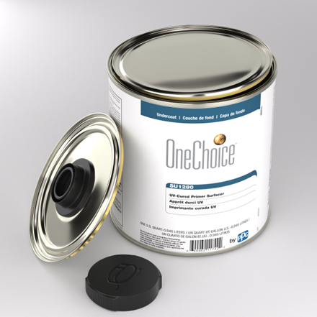
We’re excited to introduce a new accessory designed to make your UV primer experience even smoother: the Pourable Quart Lid for SU1280.
This easy-to-use lid fits directly onto our standard quart cans of SU1280 giving you greater control and precision when pouring – no more drips, spills, or wasted product.
Features & Benefits:

- Cleaner application: Reduces mess and cleanup time
- Better Control: Pour exactly what you need, where you need it
- Compatible Fit: Designed specifically for the quart-sized SU1280 UV primer cans
- Sold Separately: Add it to your order as an optional accessory

Ordering Information:

Item: | Pourable Quart Lid for SU1280
Code: | DOX704/EA
Size: | EA - each
Packaging: | 1 lid per package

Packaging Note:

SU1280/04 will continue to be shipped in its standard quart can with the original lid. The DOX704 Pourable Quart Lid is a separate purchase and can be easily swapped onto the can when you’re ready to pour.

Note: The initial launch batch will feature a red cap. Future batch will have a black cap.

