December 2025
Extra Strength Red Toners
T5320, T5350, T5380, T5450, T5470, T5480
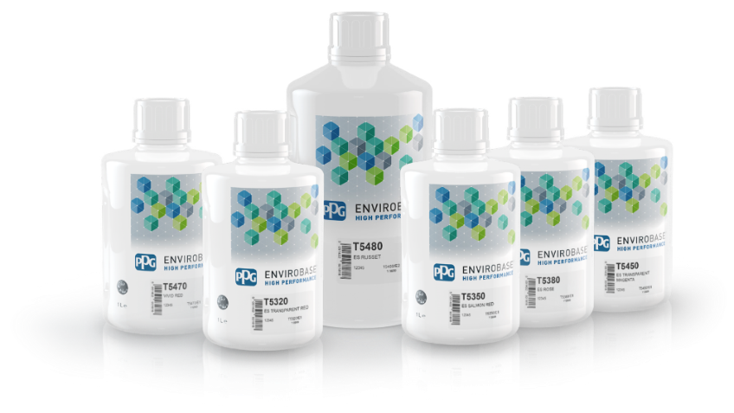
Product Information:
PPG is committed to continually providing customers with an enhanced experience through the PPG ENVIROBASE® High Performance paint line, ensuring ongoing improvements in quality, performance, and user satisfaction to support our customers' success in every application.

In line with this dedication to continuous improvement, we have developed 6 enhanced strength toners for the red color space within our Envirobase High Performance platform, featuring improved pigmentation and opacity performance.

Features & Benefits:
- Fewer Coats, Less Material: Achieve coverage with fewer coats, reducing material consumption.
- Faster Process, Higher Throughput: Faster application and drying times increase process efficiency.
- Consistent Color Matching: Reliable, repeatable color accuracy, minimizing the need for adjustments and rework.
- Easy Mixing: The new Extra Strength toners are simple to use with no change in current mixing ratios for Envirobase High Performance waterborne basecoat system. The six new toners integrate seamlessly with current mix schematics and PPG MOONWALK® paint mixing system.

Color Information:
The pigments used in the new Extra Strength toners deliver enhanced opacity and higher chroma in all angles.
This results in a better overall color capability, especially in bright and transparent basecoat reds and in 3CT layers where chromaticity and opacity are crucial.

General color matching guidelines remain the same as Envirobase High Performance. All toners are:
- Valid in basecoat and midcoat
- Can be blended with other toners

The New Extra Strength Toners are an advancement over the current toners, therefore there should be a plan in place to remove the following products:

- T432/1L to be replaced with T5320/1L
- T435/1L to be replaced with T5350/1L
- T438/1L to be replaced with T5380/1L
- T445/1L to be replaced with T5450/1L
- T447/1L to be replaced with T5470/1L
- T448/2L to be replaced with T5480/2L

To support the launch of our new Extra Strength toners, we will be providing two dedicated paint lines in PPG LINQ™ Color and PAINTMANAGER®XI color management software:

- Standard EHP Paint Line (currently available)
- PPG EHP Extra Strength Toners Paint Line (copy of current PPG EHP Paint Line + Extra Strength Toner Formulas)

This strategic approach ensures a smooth transition and maximizes customer benefits such as:
- Color formulas accessibility (both old/new)
- Customers’ freedom using current toners/Extra Strength toners
- Better stock management
- Controlled toners launch and conversion

Ordering Information:

Code: | T5320 | T5350 | T5380
Description: | ES Transparent Red | ES Salmon Red | ES Rose
Item Number: | T5320/1L | T5350/1L | T5380/1L
Size: | 1 Liter | 1 Liter | 1 Liter
Container: | Plastic | Plastic | Plastic
Packaging: | 3 per case | 3 per case | 3 per case

Code: | T5450 | T5470 | T5480
Description: | ES Transparent Magenta | Vivid Red | ES Russet
Item Number: | T5450/1L | T5470/1L | T5480/2L
Size: | 1 Liter | 1 Liter | 2 Liters
Container: | Plastic | Plastic | Plastic
Packaging: | 3 per case | 3 per case | 2 per case

